**Day 3**

**USE Northwind from Kaggle:**

1) Update the categoryName From “Beverages” to "Drinks" in the categories table.

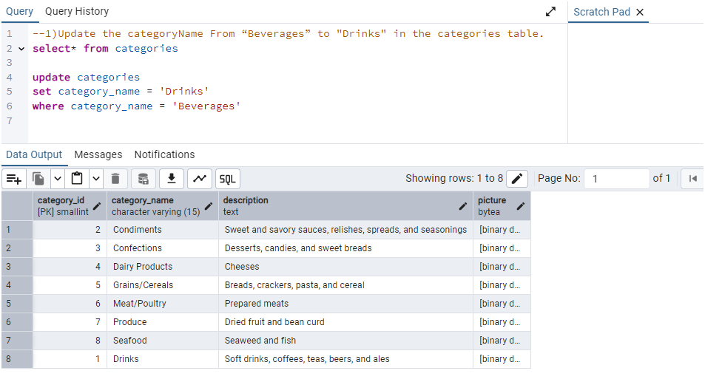

2) Insert into shipper new record (give any values) Delete that new record from shippers table.

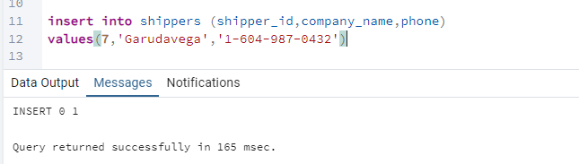Output:

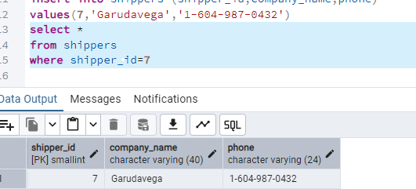

3) Update categoryID=1 to categoryID=1001. Make sure related products update their categoryID too. Display the both category and products table to show the cascade.

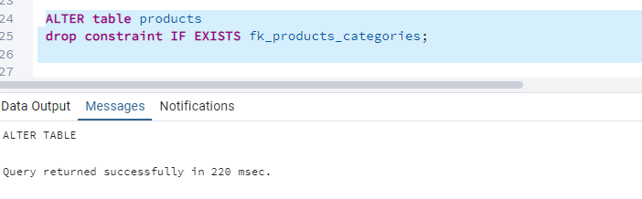OUTPUT: 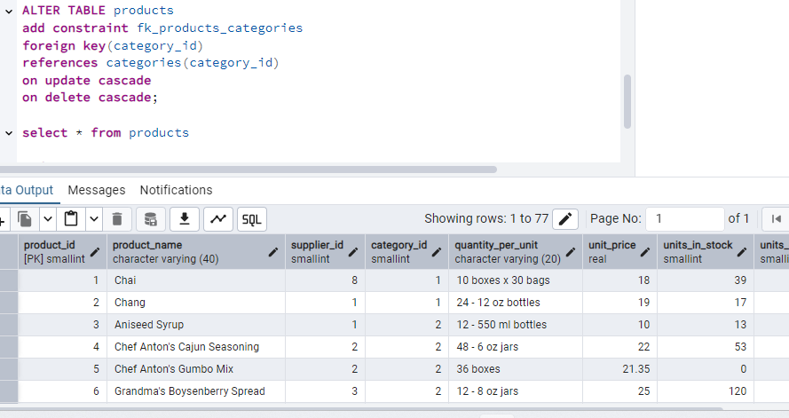

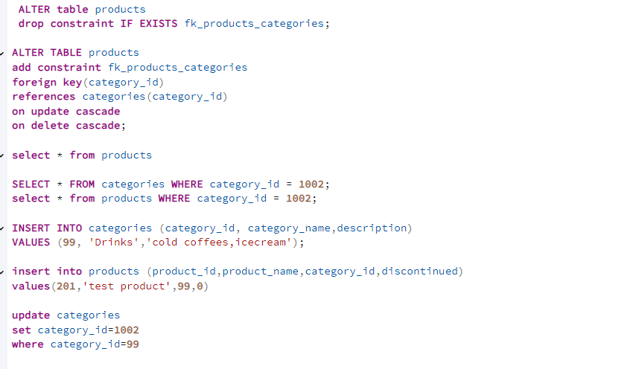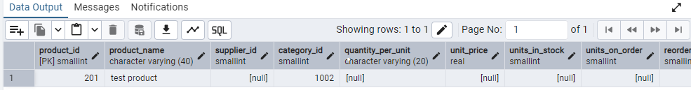

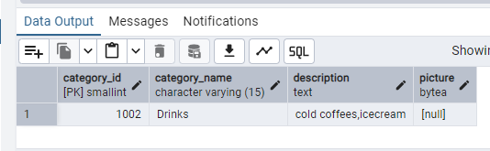

Delete the categoryID= “3” from categories. Verify that the corresponding records are deleted automatically from products.

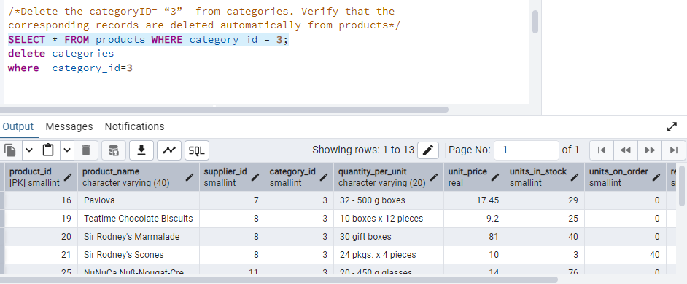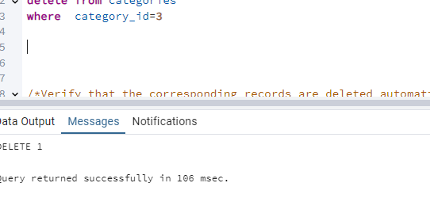

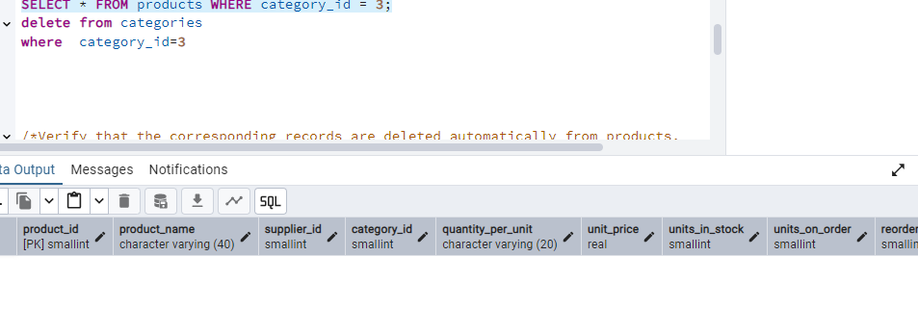OUTPUT: 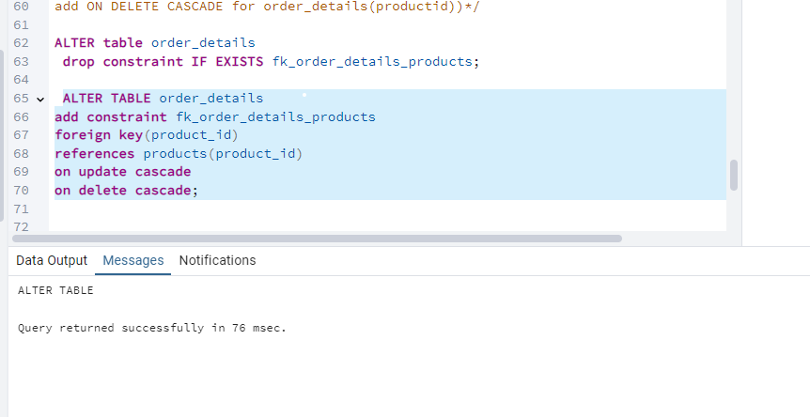

Alter the foreign key on products(categoryID) to add ON UPDATE CASCADE, ON DELETE CASCADE, add ON DELETE CASCADE for order_details(productid) )

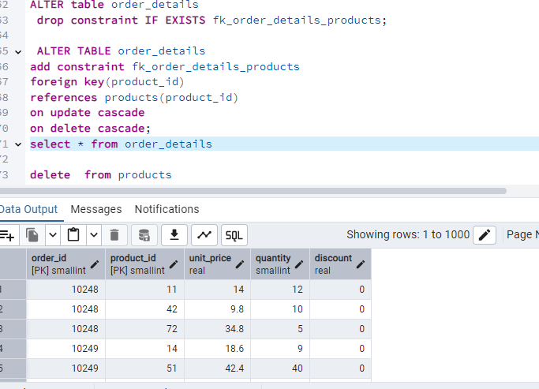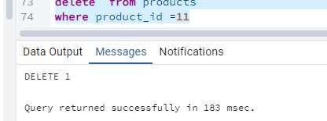

OUTPUT:

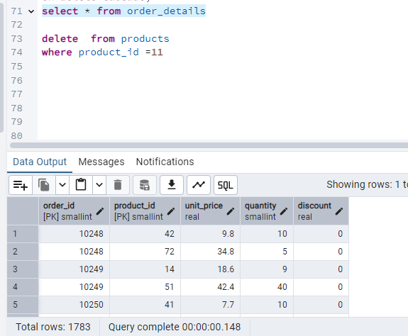

4) Delete the customer = “VINET” from customers. Corresponding customers in orders table should be set to null (HINT: Alter the foreign key on orders(customerID) to use ON DELETE SET NULL)

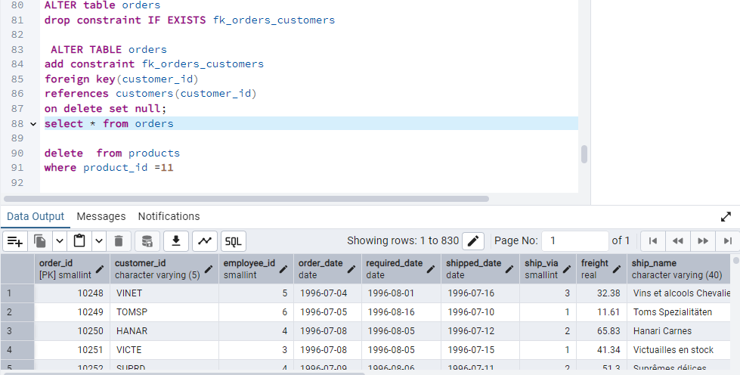OUTPUT:

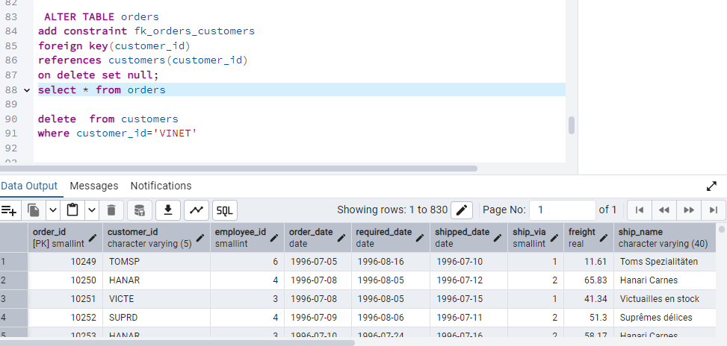

5) Insert the following data to Products using UPSERT:

Insert Product_id = 100

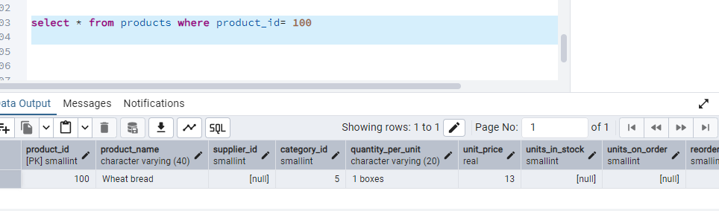Again inserting product_id=1

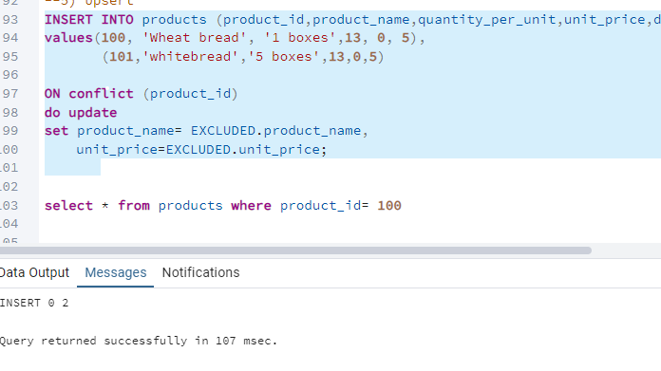

OUTPUT: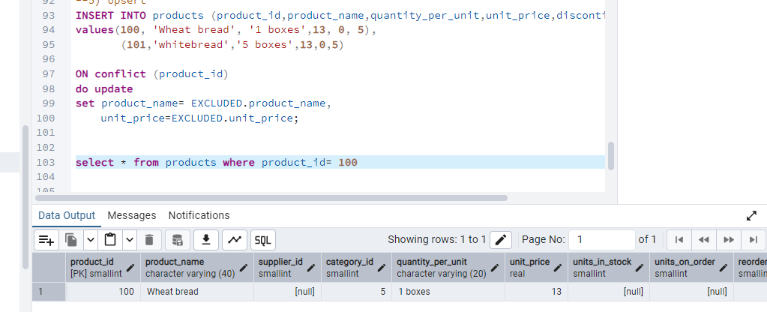

6) Write a **MERGE query**:

Create **temp table with name:** ‘updated_products’ and insert values as below:

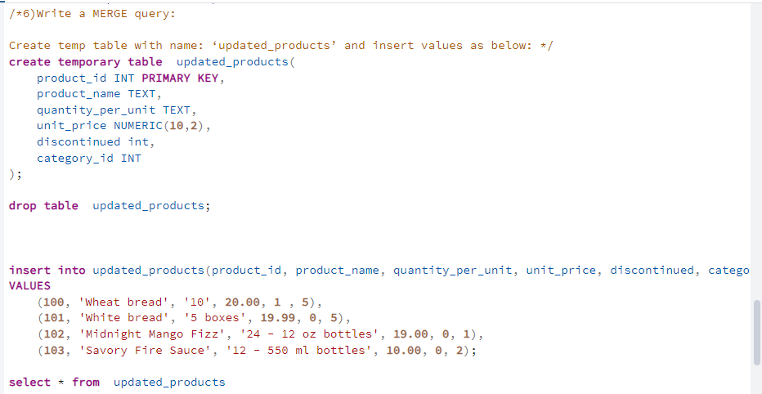OUTPUT:

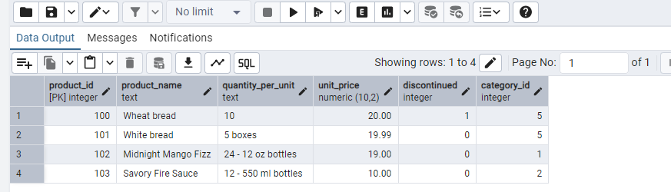

* Update the price and discontinued status for from below table ‘updated_products’ only if there are matching products and updated_products .discontinued =0
* If there are matching products and updated_products .discontinued =1 then delete
* Insert any new products from updated_products that don’t exist in products only if updated_products .discontinued =0.

**OUTPUT:**

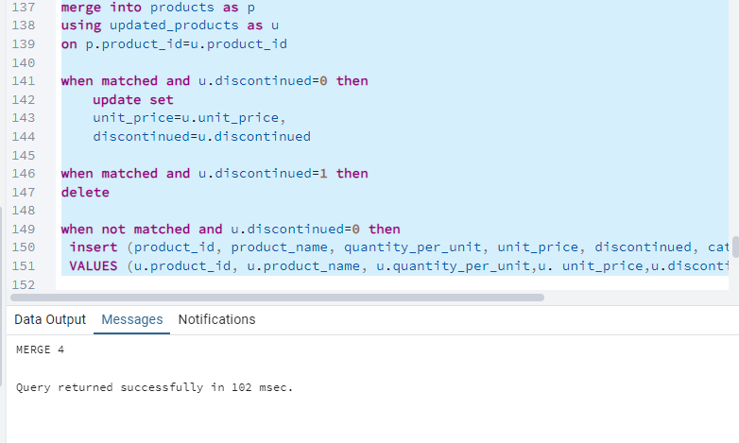

Output: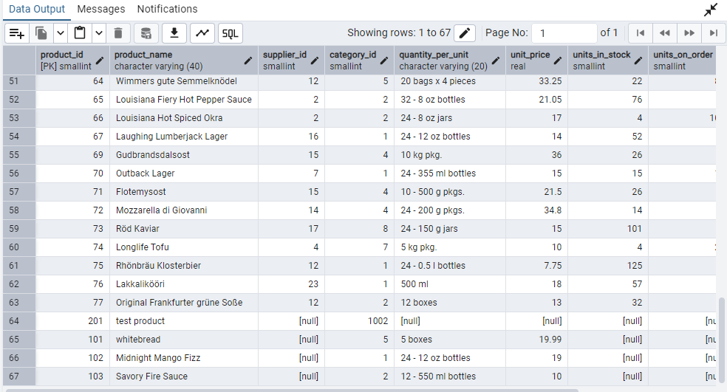

7) List all orders with employee full names. (Inner join)

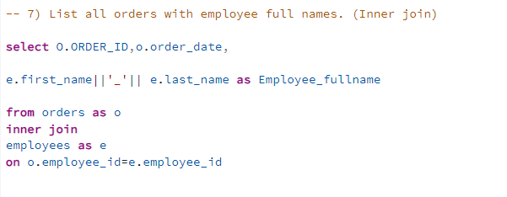

OUTPUT:

